Internal Cicuit:

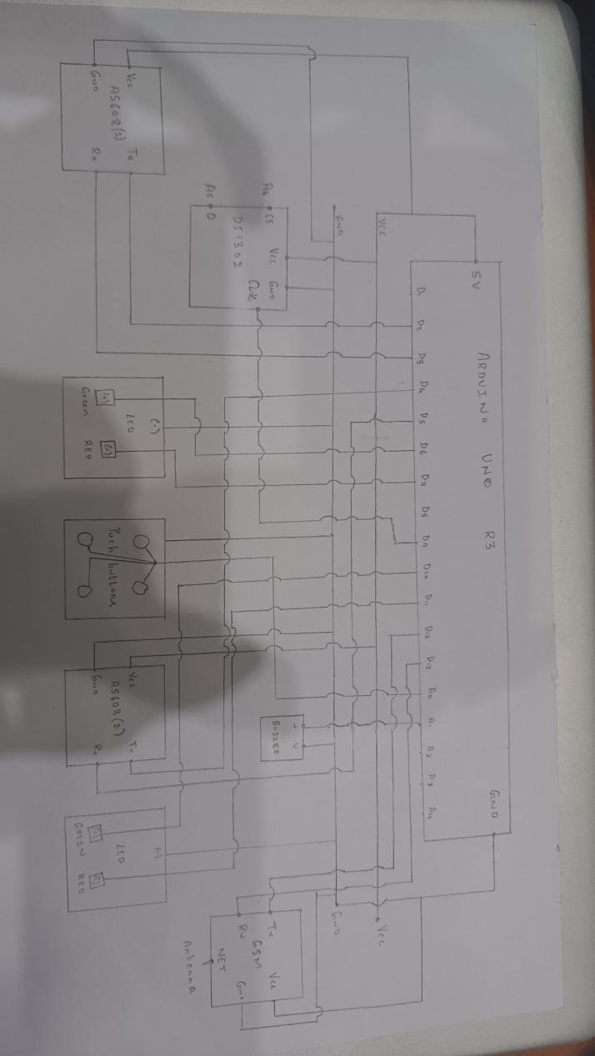

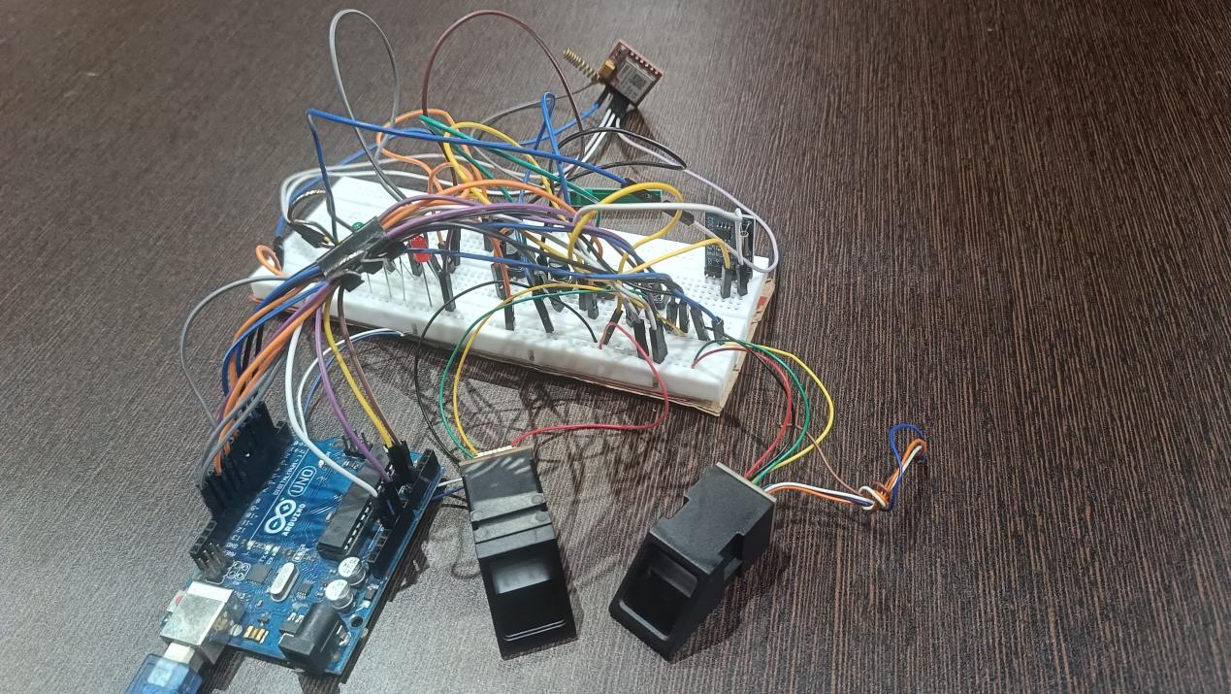

Harware Setup:

|  |  |  |
| --- | --- | --- |
| **Component:** | **Connection:** | **Function:** |
| Arduino Uno |  | Main processing unit |
| RTC DS1307 | SDA → A4, SCL → A5, VCC → 5V, GND → GND | Provides timekeeping for shift allocation |
| AS608 Sensor 1 (Entry Verification) | TX → D2, RX → D3, VCC → 5V, GND → GND | Verifies employee & voter (index fingerprint) |
| AS608 Sensor 2 (Vote Confirmation) | TX → D4, RX → D5, VCC → 5V, GND → GND | Confirms voter (thumb fingerprint) |
| GSM Module |  | Sends digital slips and reminder |
| Push Buttons | D12, D13, A0, A1 (with internal pull-up; other terminal to GND) | Registers party selection |
| LEDs (Entry Verification) | Green: D6, Yellow: D7, Red: D8 | Visual status indicators for entry verification |
| LEDs (Vote Confirmation) | Green: D10, Red: D11 (each via 220 Ω resistor to GND) | Visual status indicators for vote confirmation |

